
LjunggrenAudio RYO Optodist:
an OptoVCA with distortion and LED limiting.

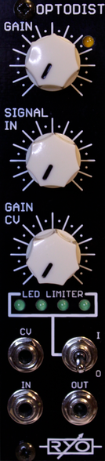

- distortion with characterful overdriven sound.
- VCA.
- on board LED limiter circuit soft-clips signal through 4 LEDs on front panel for a different flavour of distortion.
- basic manual attenuator.
- analogue optocouplers used for Non-intrusive voltage control of VCA.
- All analogue circuitry.
- hi-fidelity signal chain with low noise opamps.
- Buffered inputs and outputs.
- slim 6HP footprint.
- compact 31mm Depth (with power cable attached).
- low power draw: 16mA +12V / 16mA -12V / no +5V required.
- Works for audio as well as CV.
- plucky dynamic CV response.

downloads
* user manual
* quickstart guide
* assembly guide
* hi-res schematic
* datasheet
* BOM

